For sample_1 and sample_1
Folder structure
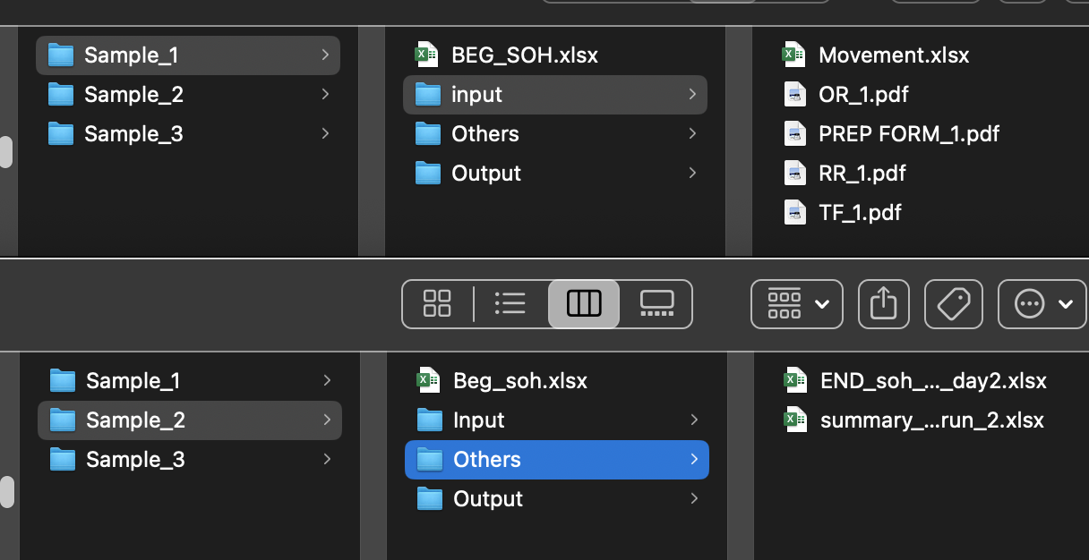
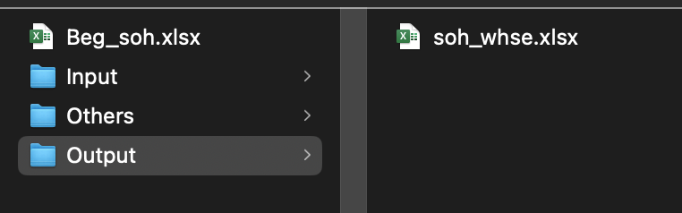
Input folder is the 4 forms plus an excel distilling the forms in an excel
Others – you can ignore this as this is only an analysis of whse report vs the computed report done by the program and why there are differences. This is purely optional and you can chek this if you want ONLY if your program is working
Output – my output and this should be also your output. If its not then pls chk your work carefully before emailing me to save me time. Do a manual compute first
These are 2 samples or 2 separate scenarios. THEY ARE NOT CONNECTED TO EACH OTHER . Each has its own beginning SOH

For Sample 3
Folder structure
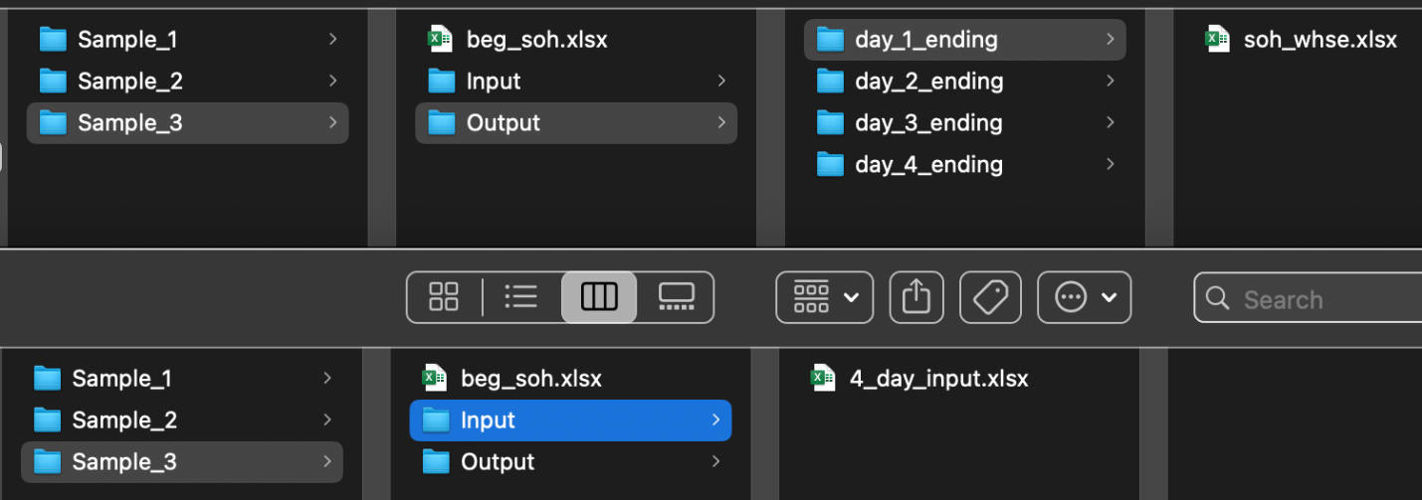
Pls chk 4_day_input excel and notes tab
Soh_whse.xlsx is the beg inv for day 1, then you are to generate ending soh on day 1 and that will be the beg soh for day 2 and so on
4_day_input are the movement of RM for 4 days
Output folder has 4 subfolders and those are the ending soh I generated so pls generate them also in your program and compare your result to this. If we are not the same pls chk why there is a diff and double chk before emailing me

Sample 3 is independent of sample 1 and 2

Note that the output (soh_whse.xlsx) needs to be in the same format. First tab is NOTES, then WHSE1, WHSE2,WHSE3.
For notes : Cell B2 must be a date in the same format
For whse1,2,4 : Col B C and C must exist, Follow the order of the columns and the name of the column ; cell A1 must be a date in the same format

